**Exercise 1: Setting Up Junit**

***FirstTest.java***

package junit;  
import org.junit.Test;  
  
public class FirstTest {  
 @Test  
 public void sampleTest(){  
 System.*out*.println("Junit is set up.");  
 }  
}

**Output:**

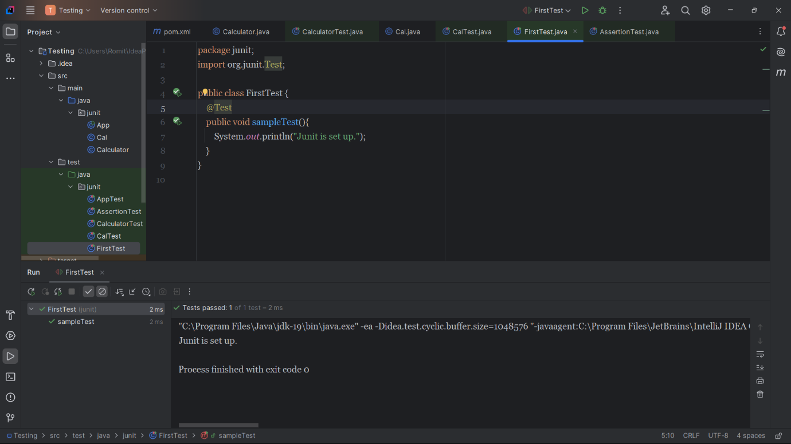

**Exercise 2: Writing Basic JUnit Tests**

***Calculator.java***

package junit;  
  
public class Calculator {  
 public int add(int a, int b) {  
 return a + b;  
 }

public int subtract(int a, int b) {  
 return a - b;  
 }  
  
 public int multiply(int a, int b) {  
 return a * b;  
 }  
  
 public int divide(int a, int b) {  
 if (b == 0) throw new IllegalArgumentException("Division by zero");  
 return a / b;  
 }  
}

***CalculatorTest.java***

package junit;  
import org.junit.Test;  
import static org.junit.Assert.*;  
  
public class CalculatorTest {  
 Calculator calculator = new Calculator();  
  
 @Test  
 public void testAdd() {  
 *assertEquals*(10, calculator.add(7, 3));  
 }  
  
 @Test  
 public void testSubtract() {  
 *assertEquals*(4, calculator.subtract(7, 3));  
 }  
  
 @Test  
 public void testMultiply() {  
 *assertEquals*(21, calculator.multiply(7, 3));  
 }  
  
 @Test  
 public void testDivide() {  
 *assertEquals*(2, calculator.divide(6, 3));  
 }  
  
 @Test(expected = IllegalArgumentException.class)  
 public void testDivideByZero() {  
 calculator.divide(10, 0);  
 }  
}

**Output:**

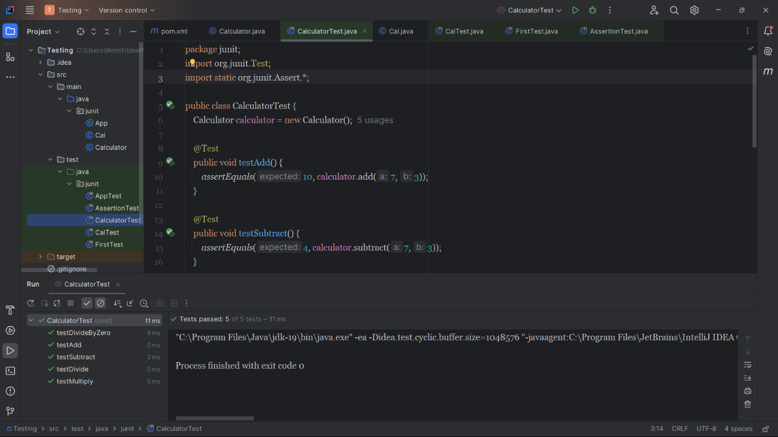

**Exercise 3: Assertions in Junit**

***AssertionTest.java***

package junit;  
import org.junit.Test;  
import static org.junit.Assert.*;  
  
public class AssertionTest {  
 @Test  
 public void testAssertions() {  
 *assertEquals*(5, 2 + 3);  
 *assertTrue*(5 > 3);  
 *assertFalse*(5 < 3);  
 *assertNull*(null);  
 *assertNotNull*(new Object());  
 }  
}

**Output:**

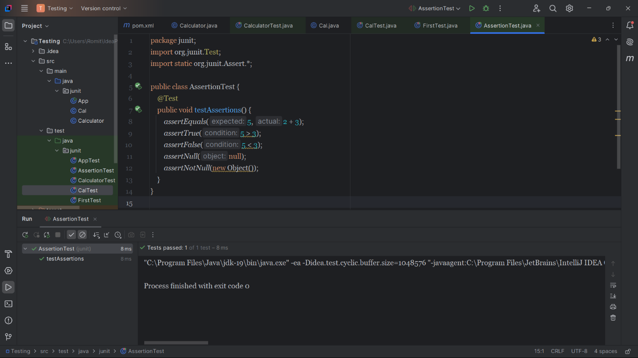

**Exercise 4: AAA Pattern, Test Fixtures, Setup and Teardown Methods in Junit**

***Cal.java***

package junit;  
  
public class Cal {  
 public int add(int a, int b) { return a + b; }  
 public int subtract(int a, int b) { return a - b; }  
 public int multiply(int a, int b) { return a * b; }  
 public int divide(int a, int b) {  
 if (b == 0) throw new IllegalArgumentException("Cannot divide by zero");  
 return a / b;  
 }  
}

***CalTest.java***

package junit;  
import org.junit.After;  
import org.junit.Before;  
import org.junit.Test;  
import static org.junit.Assert.*;  
  
public class CalTest {  
 private Calculator calculator;  
  
 @Before  
 public void setUp() {  
 System.*out*.println("Setting up Calculator instance...");  
 calculator = new Calculator();  
 }  
  
 @After  
 public void tearDown() {  
 System.*out*.println("Cleaning up...");  
 calculator = null;  
 }  
   
 @Test  
 public void testAdd() {  
 // Arrange (already done in setup)  
 // Act  
 int result = calculator.add(10, 5);  
 // Assert  
 *assertEquals*(15, result);  
 }  
  
 @Test  
 public void testDivide() {  
 int result = calculator.divide(20, 4);  
 *assertEquals*(5, result);  
 }  
  
 @Test(expected = IllegalArgumentException.class)  
 public void testDivideByZero() {  
 calculator.divide(10, 0);   
 }  
}

**Output:**

